**Project Development Phase**

**Sprint-4**

|  |  |
| --- | --- |
| Date | 14th November 2022 |
| Team ID | PNT2022TMID02193 |
| Project Name | VirtualEye – Life Guard for Swimming Pools to Detect Active Drowning |
| Maximum Marks | 4 Marks |

**Detection**

**// detection.html**

|  |
| --- |
| {% extends 'base.html' %}  {% block head %}  <link rel="stylesheet" href="styles.css">  <script src="https://ajax.googleapis.com/ajax/libs/jquery/3.6.0/jquery.min.js"></script>  <style>  #detection-about {  rotate: 270deg;  }  #detection-logout {  rotate: 270deg;  }  #detection-about:hover {  color: black;  background:rgb(67, 67, 245);  padding: 1vh;  }  #detection-logout:hover {  color: black;  background:rgb(67, 67, 245);  padding: 1vh;  }  #alert-btn:hover {  background: white;  color: black;  border-width: 0 5px 5px 0;  border-color: black rgb(67, 67, 245) rgb(67, 67, 245) black;  opacity: 100%;  }  #activateAlarm-btn:hover {  background: white;  color: black;  border-width: 0 5px 5px 0;  border-color: black rgb(67, 67, 245) rgb(67, 67, 245) black;  opacity: 100%;  }  </style>  <script>  // Potential Counter    const delay = ms => new Promise(res => setTimeout(res, ms));  const update_counter = () => {  $.ajax({  url: "/counter",  type: "POST",  dataType: "json",  success: async function(data) {  console.log("potential subject drowning: " + parseInt(data[1].slice(26,-7)))  $(object_counter).replaceWith(data)  if (parseInt(data[1].slice(26,-7)) > 0) {  await delay(2000)  }  update_counter()  }  })  }  update_counter()  </script>  {% endblock %}  {% block body %}  <body style="overflow: hidden;" class="bg-black">  <div class="container mx-auto mt-5">  <div class="container bg-black px-5 grid">  <h1 class="px-10 py-10 text-8xl text-white font-bold">v<span class="text-blue-600">eye</span></h1>  <div style="display: inline-block; position: absolute; top: 25%; right: 0">  <button id="detection-about" class="bg-black text-blue-600 text-5xl m-5 pr-2 pb-2">about</button>  </div>  <div style="display: inline-block; position: absolute; top: 60%; right: 0">  <button id="detection-logout" class="bg-black text-blue-600 text-5xl m-5 pt-2 pr-2 pb-2">logout</button>  </div>  </div>  <div>  <img style="display: inline-block; position: relative; left: 5%" class="" src="{{url_for('video')}}" width="55%"/>  <div style="display: inline-block; position: relative; top: -50px; left: 5%">  <button id="alert-btn" class="bg-black opacity-10 font-bold text-white text-5xl m-5 pr-8 pb-2">alert guards</button>  <br/>  <input id="alert-message"  style="position: absolute; width: 20vw; height: 80px; border-radius: 5px;"  class="text-2xl text-white bg-gray-700 m-5 p-2"  placeholder="type a message">  <br/>  <button style="position: fixed; margin-top: 110px" id="activateAlarm-btn" class="bg-black opacity-10 font-bold text-white text-5xl ml-5 mr-5 mb-5 pr-2 pb-2">activate alarm</button>  </div>  </div>  <div class="container bg-black px-5">  <h1 class="px-10 py-10 text-4xl text-white">potential subject drowning: <span class="text-red-500" id="object_counter">{{ dyn_var }}</span></h1>  </div>  </div>  <script type="module" src="{{ url_for('static', filename="js_modules/alarm.js") }}"></script>  <script type="module" src="{{ url_for('static', filename="js_modules/sms.js") }}"></script>  <script type="text/javascript">  var detection_logout = document.getElementById("detection-logout")  var detection_about = document.getElementById("detection-about")  var alert_btn = document.getElementById("alert-btn")  var activate_alarm = document.getElementById("activateAlarm-btn")  detection_logout.addEventListener("click", () => {  window.open("/logout", "_blank")  window.close()  })  detection_about.addEventListener("click", () => {  window.open("/about", "_blank")  window.close()  })  </script>  </body>    {% endblock %} |

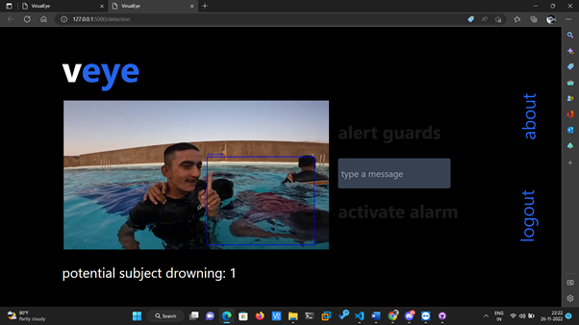

**Alarm Module**

**// alarm.js**

|  |
| --- |
| var alarm = document.getElementById("activateAlarm-btn")  var audio = new Audio("alarm.mp3")  alarm.addEventListener("click", ()=>{  // window.alert("alarm button pressed!")  audio.play()  }) |

**Logout**

**> app.py – logout section**

|  |
| --- |
| @app.route('/logout')  def logout():  if session.get("login_username"): session.pop("login_username")  if session.get("login_password"): session.pop("login_password")  if session.get("user_taken"): session.pop("user_token")  return redirect("/") |